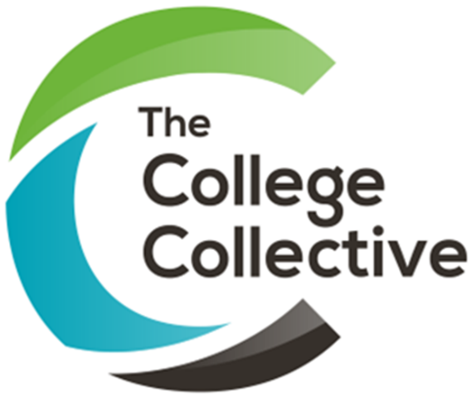

This session brought together colleagues from Sandwell College, Coleg Cambria and New College Durham to share how they are approaching staff learning and development.
The discussion explored large-scale digital CPD days, structured annual CPD programmes and on-demand learning hubs, with a strong focus on making development relevant and accessible to all staff. Colleges also shared practical approaches to using digital tools, external partners, staff feedback and data to shape and improve CPD.

Lessons learned
Lesson | What this looks like in practice
Start with staff needs | Use appraisal data, team discussions and feedback to identify priorities and shape the CPD offer.
Make CPD inclusive | Think about academic, professional services and support staff, adapting content and timings for different roles.
Keep digital CPD practical | Give staff opportunities to try tools and explore how they can be used in their day-to-day work.
Offer different ways to learn | Combine CPD days and workshops with peer learning, digital resources and on-demand learning.
Make use of external expertise | Partners such as Jisc, technology providers and other organisations can bring expertise and useful resources.
Use your own people | Staff and student digital ambassadors can support colleagues, demonstrate tools and share good practice.
Create space for sharing | Digital fairs, cafés and peer-led sessions give staff opportunities to learn from each other.
Look at impact, not just attendance | Use feedback, appraisal information and other data to understand whether CPD is making a difference.
Keep refining the approach | Learn from each CPD activity and use staff feedback to improve what you offer next.

