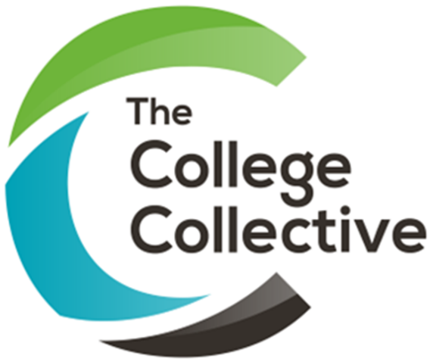

This session brought together MIS colleagues to share approaches to apprenticeship accountability, reporting, exams and funding compliance.
Stoke on Trent College shared its experience of using the apprenticeship accountability framework as an early warning tool, while West Herts College demonstrated its detailed BI reporting for apprenticeships, including off the job hours, achievement, learner barriers, attendance and engagement. MidKent College shared its approach to managing exams and MIS, including the challenges created by growing numbers of access arrangements, large exam cohorts and the need for close communication between teams.
The group also explored employer reporting, recording learner engagement, planned hours and the practical challenges of interpreting changing funding guidance.
Lessons learned
Lesson | What this looks like in practice
Keep apprenticeship accountability on the radar | Stoke on Trent College highlighted the value of monitoring the accountability framework even when performance is green, so emerging issues can be identified early.
Use data to spot problems early | West Herts College uses BI dashboards to monitor areas including off the job hours, high grades, barriers, engagement, attendance, withdrawals and documentation.
Build reporting around what teams need | West Herts College’s reporting has evolved over time, incorporating feedback and new requirements rather than trying to create the perfect system from the outset.
Think about the employer view | Providing employers with useful apprentice data can improve visibility and engagement, although extracting and presenting the right information can be technically challenging.
Be clear about evidence of engagement | When identifying a learner’s last engagement date, colleges discussed using the latest evidenced activity across off the job learning and classroom attendance.
Bring exams and MIS closer together | Stoke on Trent College and others highlighted the benefits of close collaboration, particularly during high pressure periods such as exams and enrolment.
Understand each team’s pressure points | MidKent College highlighted how better communication between exams, MIS and curriculum teams can reduce errors and make complex processes run more smoothly.
Plan for growing exam complexity | Increasing access arrangements, large GCSE and T Level cohorts and limitations in college systems can create significant operational challenges.
Keep reviewing funding guidance | The discussion around planned hours highlighted the importance of checking interpretations and sharing practice when funding guidance is unclear or changes.

